Nama : Bintang indra w

NIM : L200150050

Kelas : B

Algoritma dan Struktur data

Perbandingan Sequential search, Sequential search(Sorting),Binary search,analisis Binary search

Sequential search

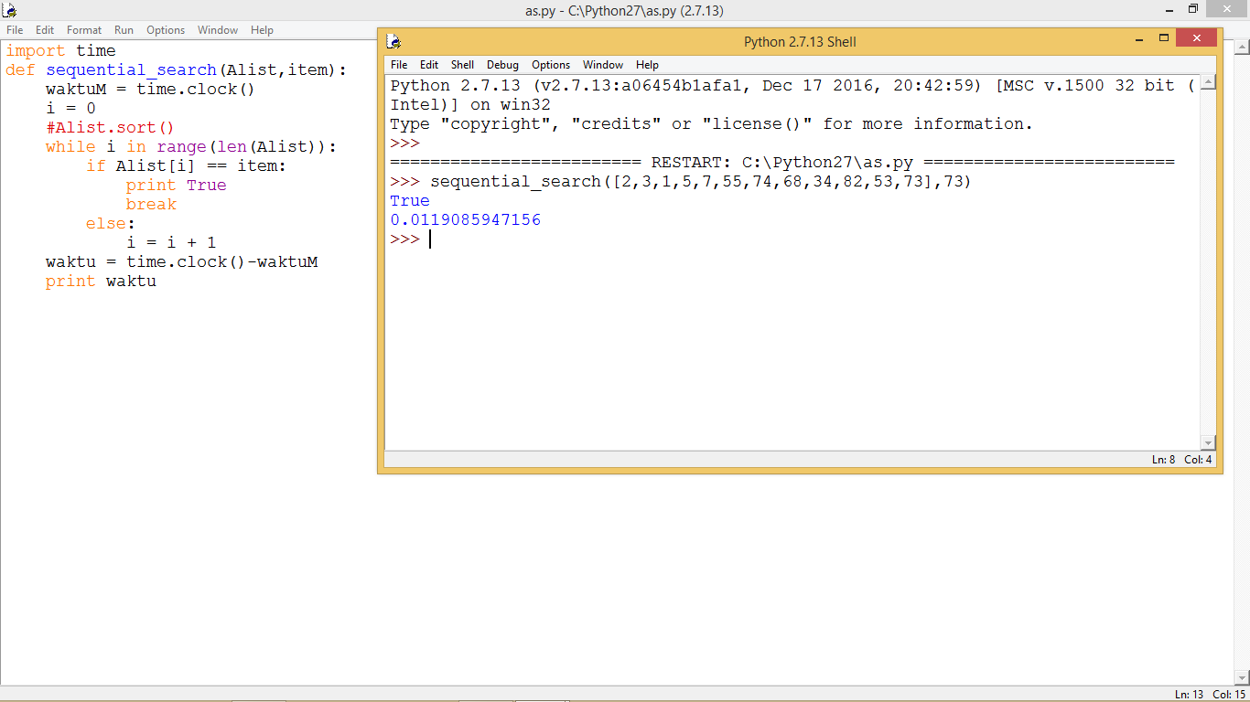

Sequential search (sorting)

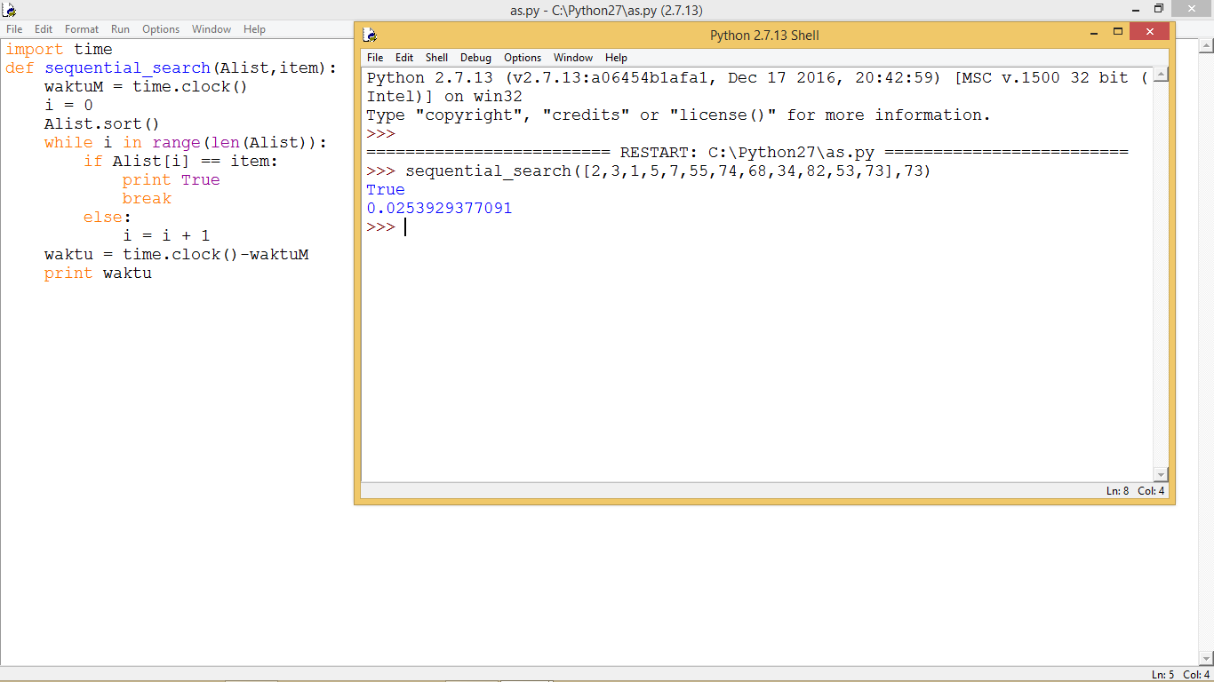

Binary searching

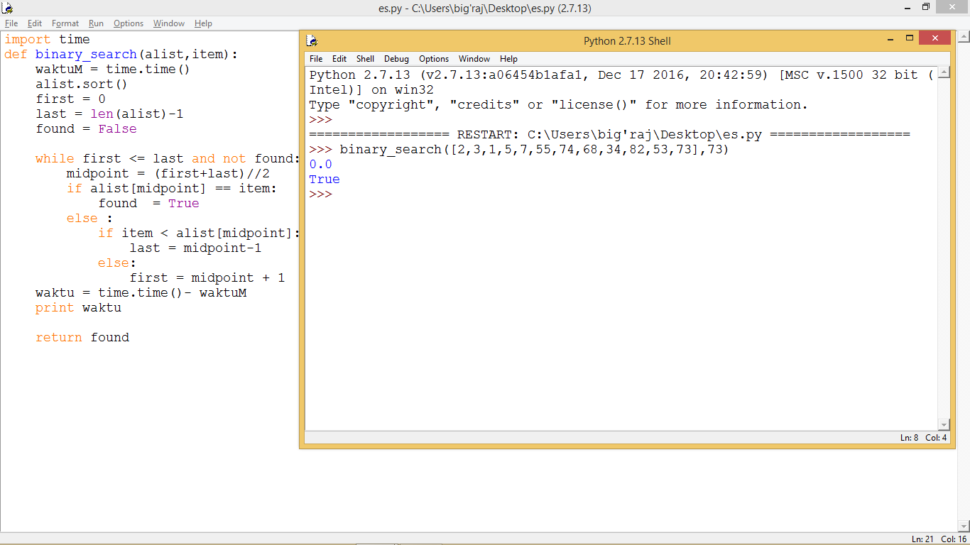

Analisis binary search